**Resumé Yongling Huang**

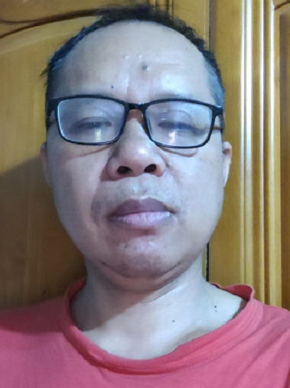

Email: littleflute@163.com

Github: [https://github.com/](https://github.com/harrypotter)littleflute

Personal site:<https://mp.weixin.qq.com/s/F23LxnCTZltr95-xs7YNZw>

**Summary**

As a full-stack developer, he has extensive experience in commercial software development using various languages, platforms and technologies. He has worked in both front-end and back-end. He is good at in object-oriented programming, proficient in Javascript, C/C++ programming languages, familiar with common data structures, algorithms, and design patterns.

**General experience**

| Roles and skills   1. Senior developer 2. Tech lead | Sectors·   1. Digital Cam 2. Media |
| --- | --- |
|  |  |

**Methods, Technologies and Environments**

| **Methods/models**   1. Scrum 2. Agile | **Language**   1. Javascript 2. C/C++ |
| --- | --- |
|  |  |

**Education and certificate**

**Mastor| 2001- 2004 |**China University of Geosciences, Beijing, China

Computer Science

**Bachelor | 1992- 1996 |**China University of Geosciences, Wuhan, Huber, China

Sciences, Geology

**Personal information**

**Year of birth** 1973

**Language**

Mandarin – Native

English – Fluent

**On my spare time**

basketball, Music.

**Previous assignments and projects**

**Senior Developer,** The Wanderers Paradise software team

**2018 – Now**

Lead the development of an open source software project, and conduct learning and development of various software projects based on github.

This is an open source project that we have been developing. Both front-end and back-end are involved. Nodejs, java spring boot, and python are used as the back-end, all of which are deployed on the cloud.

**Technical environment:** NodeJS, javascript, html, mysql, java, python, swager, AWS, c/c++, etc.;

**Role:** Senior developer

**Senior Developer,** Oregon State University GROUP6 team

2015 – 2021

The backend of this project is deployed on aws. The mobile phone client is developed with android studio （java）. I focus on nodejs backend and also involves the front end of react.

**Technical environment:** NodeJS, MySQL, javascript, html5, REACT, mysql, java;

**Role:** Senior developer

**Senior Developer,** Valley Wind Multimedia Team

2009– 2015

Responsible for music works design, release and live performance of music-related products.

1. original song and lyrics

2. Creation and operation of rock bands;

3. Design and development of digital music score editing system;

4. Design and development of performance log system.

**Technical environment:** C++, ASP, javascript, html, access;

**Role:** Senior developer

**Senior Developer,**  China Daheng Co, Daheng Image, Beijing

2004– 2009

Daheng Image digital camera driver design and computer application software development to complete real-time image data acquisition and image processing;

1. Develop Windows platform driver interface library (DLL), realize a set of layered software architecture, manage different types of camera products;

2. Develop SDK and sample programs for camera products;

3. Develop product test suites, plug-ins and custom desktop applications;

**Technical environment:** C/C++、MFC、WTL、STL、Windows API；

**Role:** Senior developer

**Developer,**  Dierao Tech Co, Beijing

2002– 2004

Program design of GIS geographic information system independently developed by Korea Dierao Company

1. Geographic Information Database Design

2. Geographic information map display program design.

**Technical environment:** C/C++、MFC、VB、Windows API；

**Role:** Developer

**Competence Matrix**

| Competence Matrix (The consultants own words) | | |
| --- | --- | --- |
| **Skills** | **Years** | **Comments** |
| Experience as frontend developer. | 10+ | I have more than 10 years experience in frontend.  I develop my own frontend library. |
| Experience as backend developer. | 10+ | Have 5 years experience in ASP at Daheng company in 2004 - 2009.  Have 3 years of experience in working with NodeJS at Group6 in 2019 - 2021  Develop my own website every week. |
| Experience as fullstack developer. |  |  |
| Java 8 and preferably Java 11 |  |  |
| Java (in total) |  |  |
| JavaScript | 10+ | I am good at JavaScript. Develop my own library. |
| HTML | 10+ | Good at HTML |
| CSS | 10+ | Good at CSS |
| C/C++ | 10+ | Have 5 years of experience in C++ at Daheng in 2004 - 2009. |
| .Net / C# |  |  |
| Python | 1 |  |
| Golang |  |  |
| Shell Script |  |  |
| NodeJS | 3 | Have 3 years of experience in working with NodeJS at Group6 in 2019 - 2021 |
| ReactJS | 1 | Have 1 years of experience in working with ReactJS in 2021 - 2022 |
| AngularJS |  |  |
| Vue |  |  |
| Android (Specify app or platform) | 3 | Have 3 years of experience in working with Android(cellphone Game develop) at Group6 in 2019 - 2021 |
| iOS |  |  |
| Cloud(AWS, GCP, Azure) | 3 | AWS Cloud |
| Micro Services | 3 | Have 3 years experience in Micro Services at Group6 in 2019 - 2021. |
| Spring Core, Spring Boot (micro service architecture) | 2 | Have 2 years experience in Spring Boot at Wanderers Paradise in 2020- 2022. |
| Test Driven Development (TDD) | 2 | Have 2 years experience in Test Driver Development at Wanderers Paradise in 2020- 2022. |
| Continuous Integration (CI) and Continuous Delivery (CD) | 2 | Have 2 years of experience in git at Wanderers Paradise in 2020- 2022. |
| JMS (Active MQ), REST |  |  |
| Test frameworks (JUnit, Mockito, Wiremock, Cucumber, etc), |  |  |
| Databases (Postgres) | 3 | Have 3 year of experience in MySQL at Group6 in 2019 - 2021. |
| NoSQL(MongoDB) |  |  |
| Docker | 1 | Have 1 years experience in Docker at Wanderers Paradise in 2020- 2022. |
| Kubernetes |  |  |
| Kafka |  |  |
| Cassandra |  |  |
| ElasticSearch |  |  |
| GIT | 5 | Have 5 years of experience in git in 2017 - 2022. |
| DevOps methodology |  |  |
|  |  |  |